ASSIGNMENT-5.1
NAME: S.Ravi Kiran H.T.NO:2303A52261 BATCH:36

Task Description #1 (Privacy in API Usage)
Task: Use an AI tool to generate a Python program that connects to a weather API.
Prompt:
"Generate code to fetch weather data securely without exposing API keys in the code."
Expected Output:
- Original AI code (check if keys are hardcoded).
- Secure version using environment variables.
CODE:
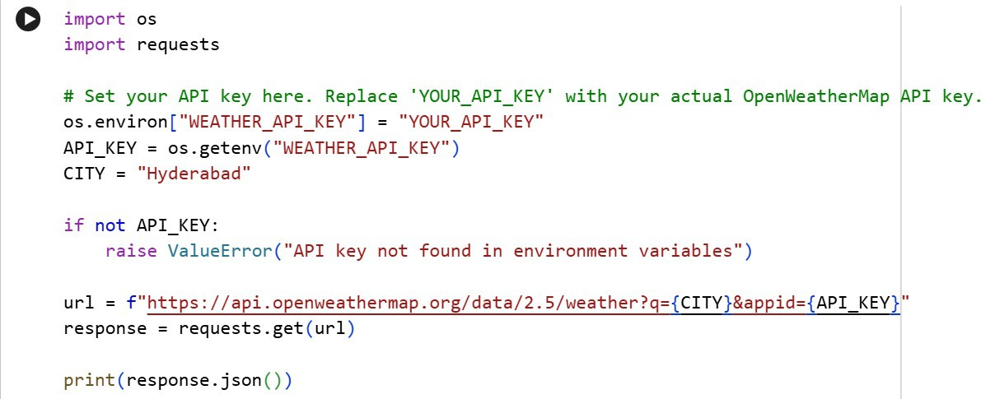
OUTPUT:

Task Description #2 (Privacy & Security in File Handling)
Task: Use an AI tool to generate a Python script that stores user data (name, email, password) in a file.
Analyze: Check if the AI stores sensitive data in plain text or without encryption.

Expected Output:
- Identified privacy risks.
- Revised version with encrypted password storage (e.g., hashing).
CODE:
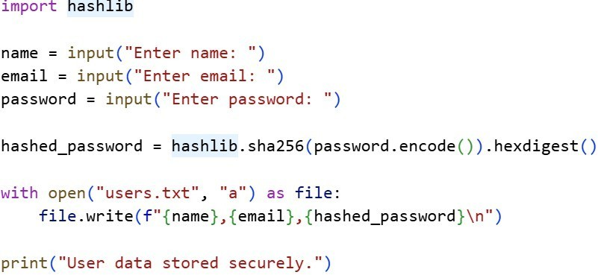

OUTPUT:

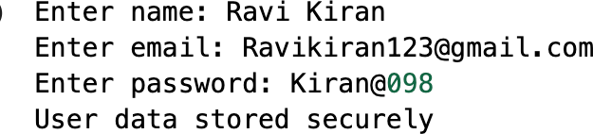

Task Description#3(Transparency in Algorithm Design)
Objective: Use AI to generate an Armstrong number checking function with comments and explanations.
Instructions:
- Ask AI to explain the code line-by-line.
- Compare the explanation with code functionality. Expected Output:

  - Transparent, commented code.
  - Correct, easy-to-understand explanation.
CODE:
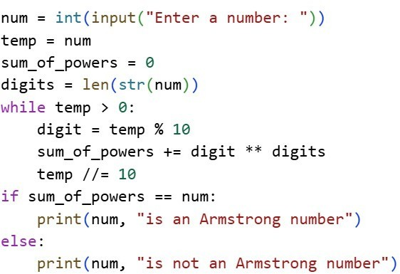

OUTPUT:
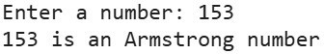

Task Description #4 (Transparency in Algorithm Comparison) Task: Use AI to implement two sorting algorithms (e.g., QuickSort and BubbleSort).
Prompt:
"Generate Python code for QuickSort and BubbleSort, and include comments explaining step-by-step how each works and where they differ." Expected Output:
  - Code for both algorithms.
  - Transparent, comparative explanation of their logic and efficiency.
CODE:
QUICK SORT:

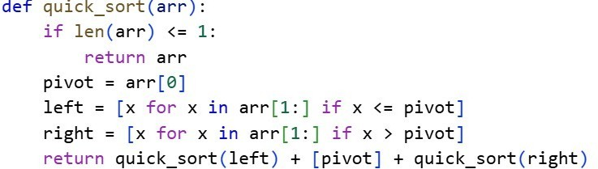

BUBBLE SORT:
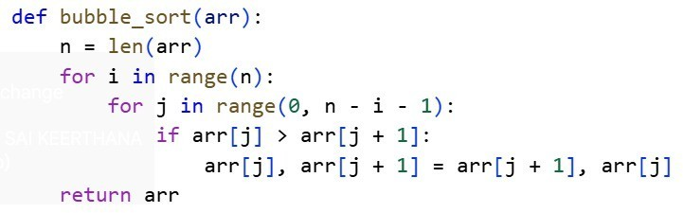

COMPARISON TABLE:
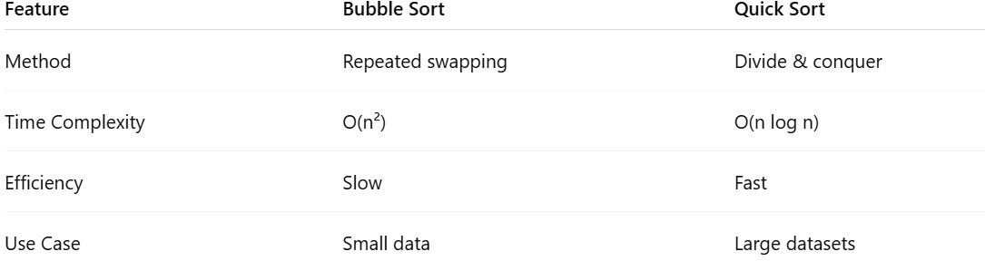

Task Description #5 (Transparency in AI Recommendations)
Task: Use AI to create a product recommendation system. Prompt:
"Generate a recommendation system that also provides reasons for each suggestion."
Expected Output:
  - Code with explainable recommendations.
  - Evaluation of whether explanations are understandable.

CODE:
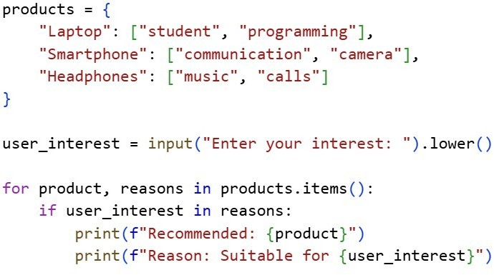

OUTPUT:
